**Ownership, Permissions and SU and SUDO Lab Name: _________________**

Reference Page

U G O

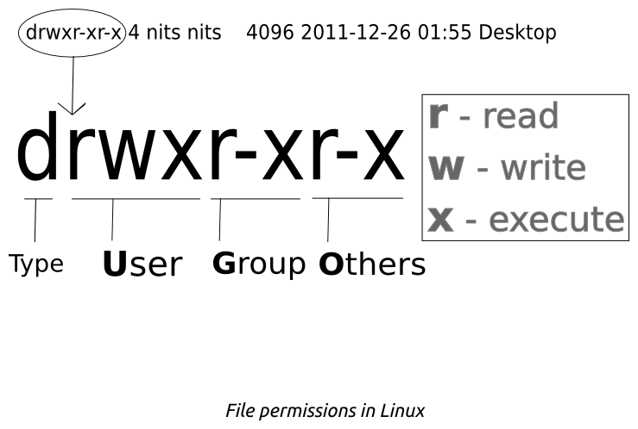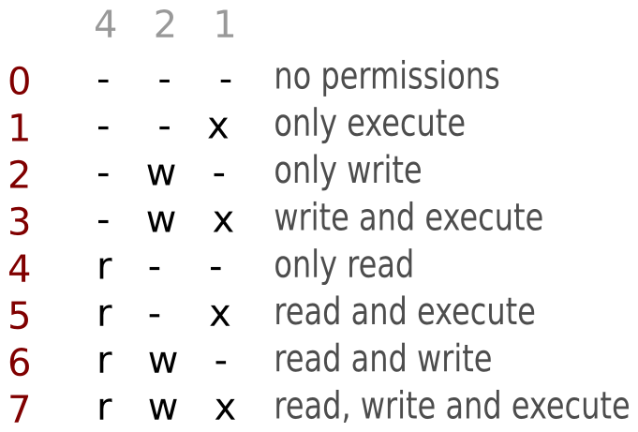

Man is your friend, use your book or Google if needed.

|  |  |
| --- | --- |
| Create a user with a home directory  **sudo useradd -m username** | Change password requirement  **Sudo chage -M 30 username** |
| Create a home directory for a user  **sudo mkhomedir_helper username** | File for user password data  **/etc/shadow** |
| Set a password for a user  **sudo passwd username** | Check File/Directory permissions  **ls –option path**  **ls -la**= with long format, show permissions |
| Create a group  **sudo groupadd groupname** | Change Group ownership  **chgrp groupname file/directoryName**  or  **chown username:groupname filename** |
| To see group membership  **id -Gn username** | Make a directory  **mkdir directoryname** |
| Add a different user to a home directory without changing ownership  **setfacl -m u:username:rwx myfolder** | Create a file  **touch filename** – creates an empty file  **nano filename** – creates file and allows input  **vi filename** – creates file and allows input |
| Add user to a group  **Sudo nano /etc/group**  or  **sudo gpasswd -a username groupname**  or  **sudo usermod username -a -G groupname** | Permissions  **chmod options permissions filename**  Examples: **chmod 775 filename**  **chmod u-x filename**  **chmod g+rw filename** |
| **pwd** = print working directory  **cd** = change directory **cd ..** = Up 1 dir.  **mkdir** = make directory | **tree** = Recursive directory listing program  **rm** = remove file  **rmdir** = remove directory |
|  |  |

Create the below: [if not already created] **No Gui allowed – Command Line only**

NOTE: check your work as you go

|  |  |  |  |
| --- | --- | --- | --- |
| Username | Password | Group Membership | Home Directory |
| ringo | drum | beatles  apple_records | All users have a home directory and full control [rwx or 7] of that directory. |
| john | imagine | beatles  apple_records  FBI |
| paul | lucy | beatles  apple_records |
| george | sun | beatles  apple_records |
| linda | photo | vis_art |
| yoko | peace | vis_art  FBI |
| epstein | manager | sudo |

Create the below directories and files under: **/usr/local**

art

contracts

music

Jude 1963 white_album

Help

File contents:

Jude - Don’t let me down Help – I need someone 1963 - Annual white_album - Snow

1. Group vis_art is the group with rwx to the art directory.
   1. Did these permissions flow down to the white_album file? ___________________
2. Group *beatles* is the group with **r** only to the 1963 file
3. “Others” will have no access at all to the *Jude* and *Help* files.
4. Add *george* as a user of *paul’s* home directory
5. Sign in as *epstein*, can you sudo? _____________________________